**Regex**

Updated: 12/31/2020 by Computer Hope

Short for **regular expression**, a **regex** is a string of text that allows you to create patterns that help match, locate, and manage text. [Perl](https://www.computerhope.com/jargon/p/perl.htm) is a great example of a [programming language](https://www.computerhope.com/jargon/p/programming-language.htm) that utilizes regular expressions. However, its only one of the many places you can find regular expressions. Regular expressions can also be used from the command line and in text editors to find text within a file.

When first trying to understand regular expressions, it seems as if it's a different language. However, mastering regular expressions can save you thousands of hours if you work with text or need to parse large amounts of data. Below is an example of a regular expression with each of its components labeled. This regular expression is also shown in the Perl programming examples shown later on this page.

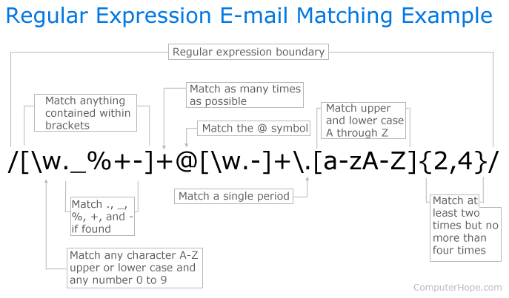

**The basics of regular expressions (cheat sheet)**

Looking at the above example may be overwhelming. However, once you understand the basic syntax of how regular expression commands operate you can read the above example as if you are reading this sentence. Unfortunately, not all programs, commands, and programming languages use the same regular expressions, but they all share similarities.

|  |  |  |  |
| --- | --- | --- | --- |
| Character | What does it do? | Example | Matches |
| **^** | Matches beginning of line | ^abc | abc, abcdef.., abc123 |
| **$** | Matches [end of line](https://www.computerhope.com/jargon/e/eol.htm) | abc$ | my:abc, 123abc, theabc |
| **.** | Match any [character](https://www.computerhope.com/jargon/c/charact.htm) | a.c | abc, asg, a2c |
| **|** | [OR](https://www.computerhope.com/jargon/o/oroperat.htm) operator | abc|xyz | abc or xyz |
| **(...)** | [Capture](https://www.computerhope.com/jargon/c/capture.htm) anything matched | (a)b(c) | Captures 'a' and 'c' |
| **(?:...)** | Non-capturing group | (a)b(?:c) | Captures 'a' but only groups 'c' |
| **[...]** | Matches anything contained in [brackets](https://www.computerhope.com/jargon/b/bracket.htm) | [abc] | a,b, or c |
| **[^...]** | Matches anything not contained in brackets | [^abc] | xyz, 123, 1de |
| **[a-z]** | Matches any characters between 'a' and 'z' | [b-z] | bc, mind, xyz |
| **{x}** | The exact 'x' amount of times to match | (abc){2} | abcabc |
| **{x,}** | Match 'x' amount of times or more | (abc){2,} | abcabc, abcabcabc |
| **{x,y}** | Match between 'x' and 'y' times. | (a){2,4} | aa, aaa, aaaaa |
| **\*** | [Greedy](https://www.computerhope.com/jargon/g/greedy.htm) match that matches everything in place of the * | ab*c | abc, abbcc, abcdc |
| **+** | Matches character before + one or more times | a+c | ac, aac, aaac, |
| **?** | Matches the character before the ? zero or one times. Also, used as a non-greedy match | ab?c | ac, abc |
| **\** | Escape the character after the backslash or create an [escape sequence](https://www.computerhope.com/jargon/e/escasequ.htm). | a\sc | a c |

**Escape characters (escape sequence)**

**Note**

Escape characters are case sensitive.

|  |  |
| --- | --- |
| Character | What does it do? |
| **\** | Any character not mentioned below preceded with a \ will be escaped. For example, \. matches a period and does not perform the function mentioned above. Characters that should be escaped are () [] {} ^ $ . | * + ? \ |
| **\0** | [Null](https://www.computerhope.com/jargon/n/null.htm) character. |
| **\a** | In [Perl](https://www.computerhope.com/jargon/p/perl.htm), \a is a bell or alarm and is not used in regular expressions. |
| **\A** | Match the start of a multiline string. |
| **\b** | Word boundary in most or backspace. |
| **\B** | Non word boundary. |
| **\d** | Match any [decimal](https://www.computerhope.com/jargon/d/digit.htm) digit (0-9). |
| **\D** | Match any non digit. |
| **\e** | Match an escape. |
| **\f** | Match a [form feed](https://www.computerhope.com/jargon/f/formfeed.htm). |
| **\n** | Match a [new line](https://www.computerhope.com/jargon/n/newline.htm). |
| **\Q...\E** | Ignores any special meaning in what is being matched. |
| **\r** | Match a [carriage return](https://www.computerhope.com/jargon/c/cr.htm). |
| **\s** | Matches a [space](https://www.computerhope.com/jargon/s/spacebar.htm) character (space, \t, \r, \n). |
| **\S** | Matches any non-white space character. |
| **\t** | Match a [tab.](https://www.computerhope.com/jargon/t/tab.htm) |
| **\v** | Match a vertical tab. |
| **\w** | Matches any one word [character](https://www.computerhope.com/jargon/c/charact.htm) ([a-zA-Z_0-9]). |
| **\W** | Matches any one non-word character. |

**Regular expression flags**

Outside the regular expression (at the end) flags helps with the pattern matching.

|  |  |
| --- | --- |
| Character | What does it do? |
| **i** | Ignore the [case](https://www.computerhope.com/jargon/c/case.htm) ([uppercase](https://www.computerhope.com/jargon/u/uppercase.htm) and [lowercase](https://www.computerhope.com/jargon/l/lowercas.htm) allowed). |
| **m** | Multi-line match. |
| **s** | Match new lines. |
| **x** | Allow spaces and comments. |
| **J** | Duplicate group names allowed. |
| **U** | [Ungreedy](https://www.computerhope.com/jargon/g/greedy.htm) match. |

**Perl programming language regular expression examples**

Below are a few examples of regular expressions and pattern matching in Perl. Many of these examples are similar or the same to other programming languages and programs that support regular expressions.

$data =~ s/bad data/good data/i;

The above example replaces any "bad data" with "good data" using a [case-insensitive](https://www.computerhope.com/jargon/c/casesens.htm) match. So if the $data [variable](https://www.computerhope.com/jargon/v/variable.htm) was "Here is bad data" it would become "Here is good data".

$data =~ s/a/A/;

This example replaces any lowercase **a** with an uppercase **A**. So if $data was "example" it would become "exAmple".

$data =~ s/[a-z]/*/;

The above example replaces any lowercase letter, a through z, with an asterisk. So if $data was "Example" it would become "E******".

$data =~ s/e$/es/;

This example uses the $ character, which tells the regular expression to match the text before it at the end of the string. So if $data was "example" it would become "examples".

$data =~ s/\./!/;

In the above example, we are replacing a [period](https://www.computerhope.com/jargon/p/period.htm) with an [exclamation mark](https://www.computerhope.com/jargon/e/exclamation-mark.htm). Because the period is a [metacharacter](https://www.computerhope.com/jargon/m/metachar.htm) if you only entered a period without the \ ( [escape](https://www.computerhope.com/jargon/e/esc.htm)) it is treated as any character. In this example, if $data were "example." it would become "example!", however, if you did not have the escape it would replace every character and become "!!!!!!!!"

$data =~ s/^e/E/;

Finally, in this above example the [caret](https://www.computerhope.com/jargon/c/caret.htm) ( ^ ) tells the regular expression to match anything at the beginning of the line. In this example, any lowercase "e" at the beginning of the line is replaced with a capital "E." Therefore, if $data was "example" it would become "Example".

**Tip**

If you want to explore regular expressions even more in commands like [grep](https://www.computerhope.com/unix/ugrep.htm), or regular expressions in programming language's check out the [O'Reilly book "Mastering regular expressions](https://www.computerhope.com/cgi-bin/google.pl?mastering+regular+expressions)."